

**Telecommunication Software**

Forth Practical Exercise

Full name: **Mithin kumar Ananthula**

ID: **241AEM014**

**Riga 2024**

Table of Contents

Example 1: 3

Example 2: 5

Example 3: 5

Example 4: 7

Example 5 8

Example 6: 10

# Example 1:

Please test requests Python library, including seven types of methods and 13 parameters to control access, as I showed in the class. Please give as many different outputs as you can.

Code:

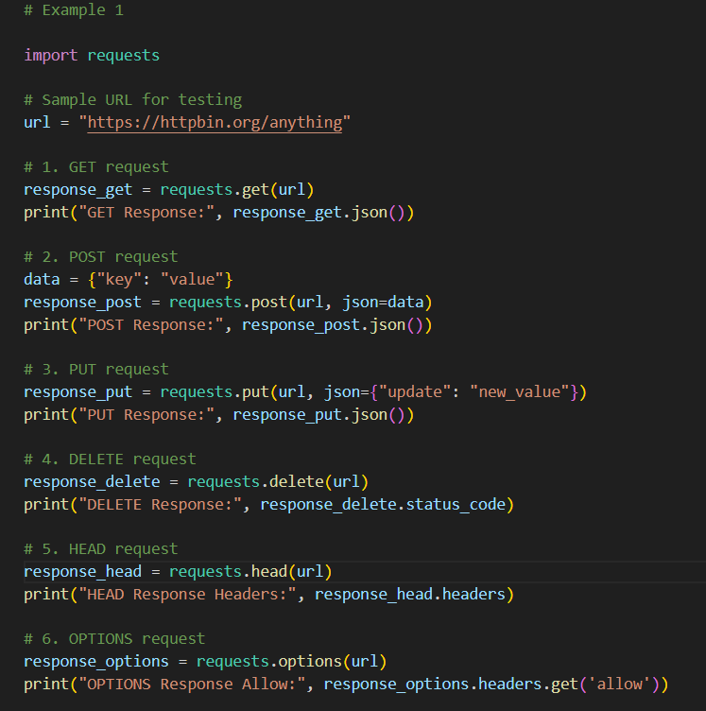

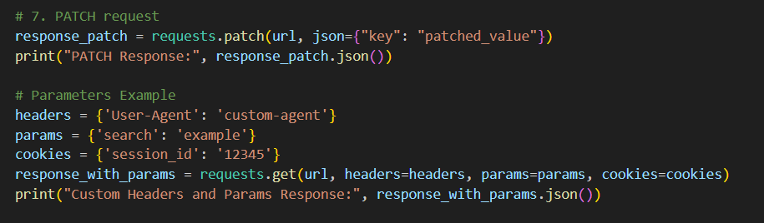

Result

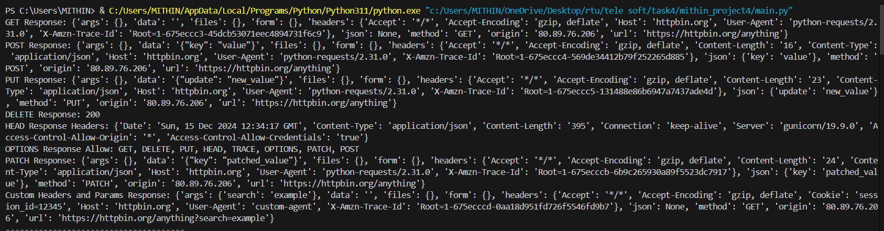

# Example 2:

Search engine keyword submission interface with requests python library.

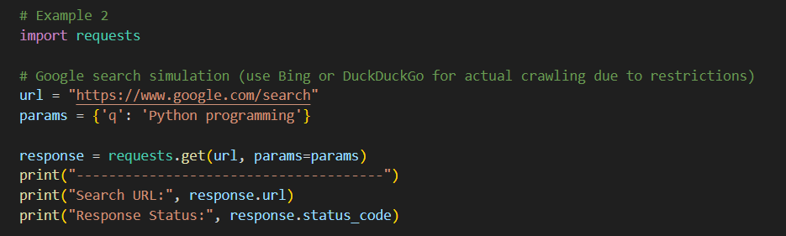

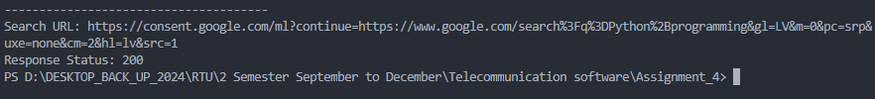

# Example 3:

Image crawling.

Code

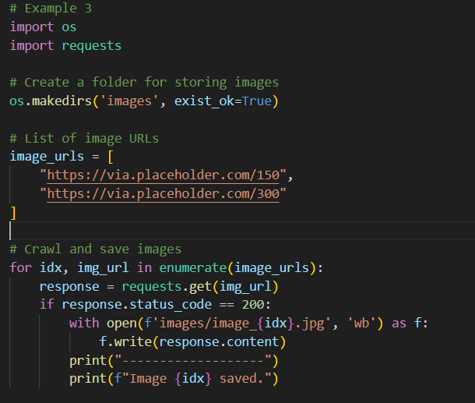

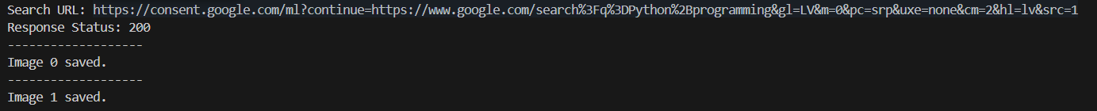

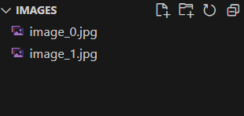

# Example 4:

University ranking print

Code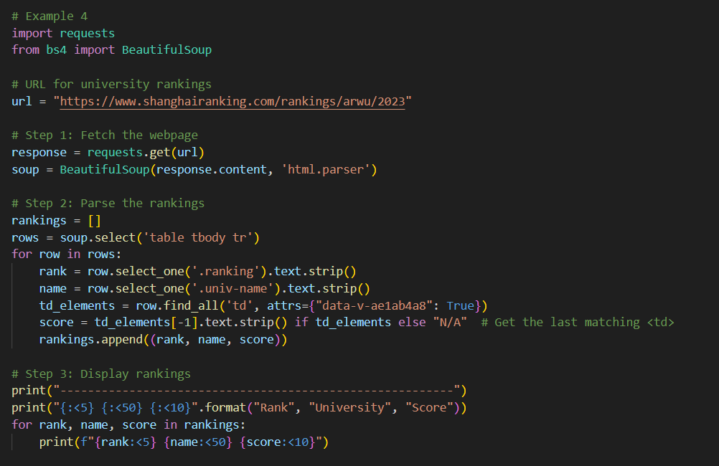

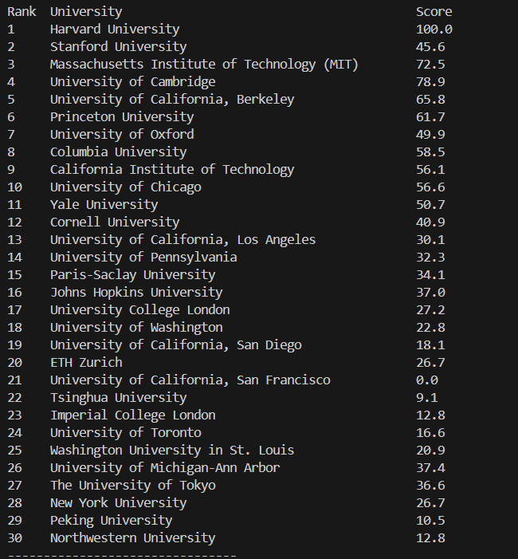

# Example 5

Crawling of goods web pages and printing relevant numbers, goods names, and prices with requests from the Python library.

Fetching product details (numbers, names, prices) from a webpage.

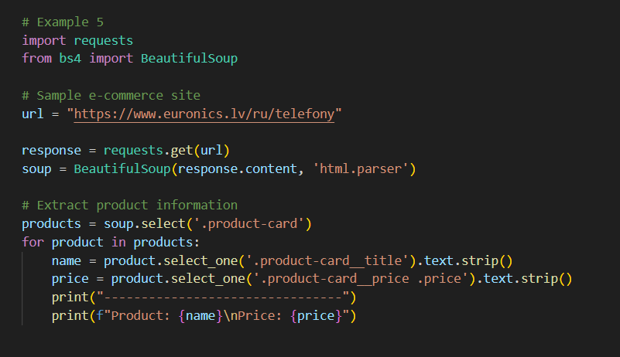

Result

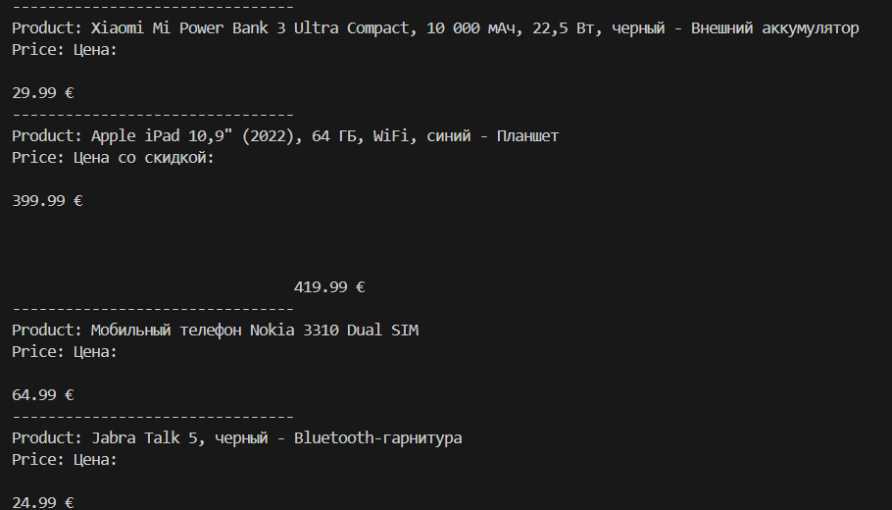

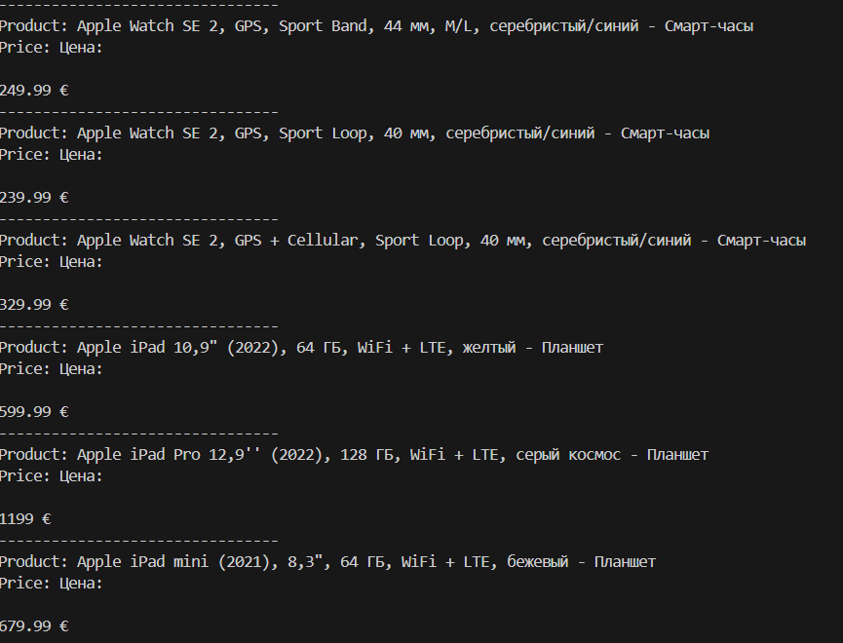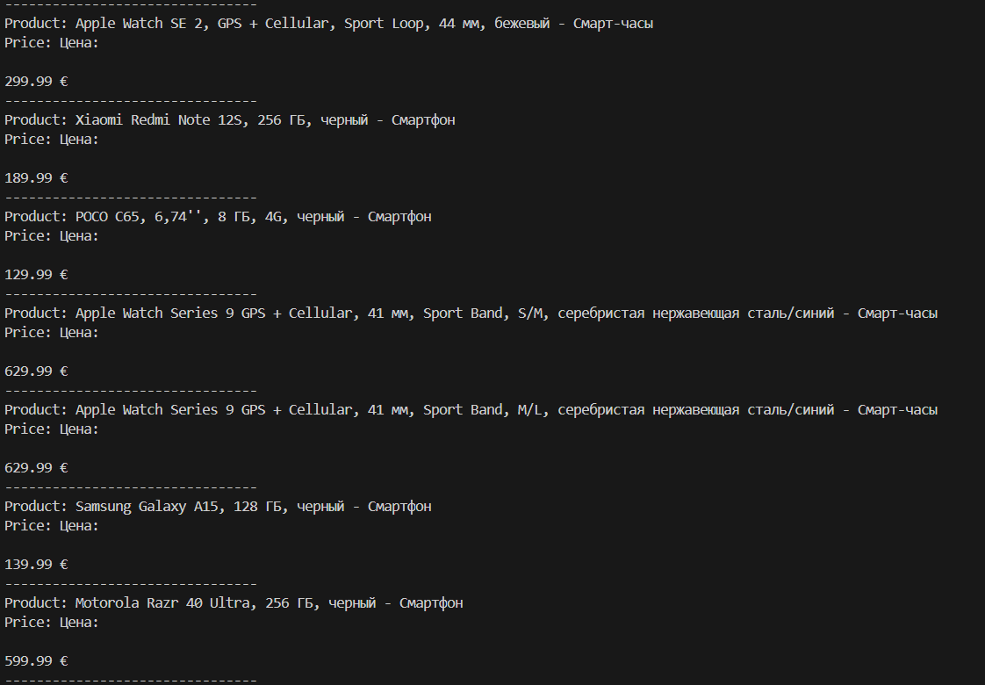

# Example 6:

Please reference two public projects finishing your Scrapy project. I recommend you continue to complete the University ranking example with Scrapy and give output with a TxT file or other format. You are welcome to share your model if you have any other ideas.

**Steps commands**

1. Install Scrapy: pip install scrapy.
2. Python -m scrapy runspider main.py -o output.json



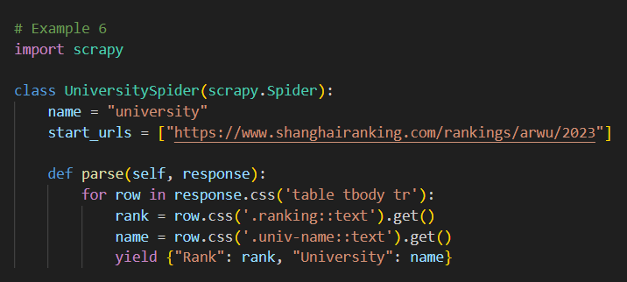

Terminal out put:

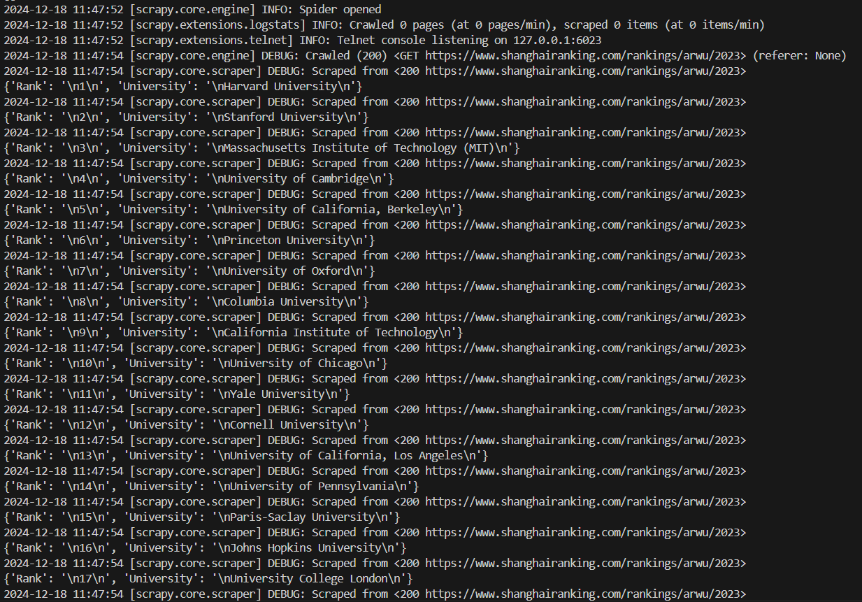

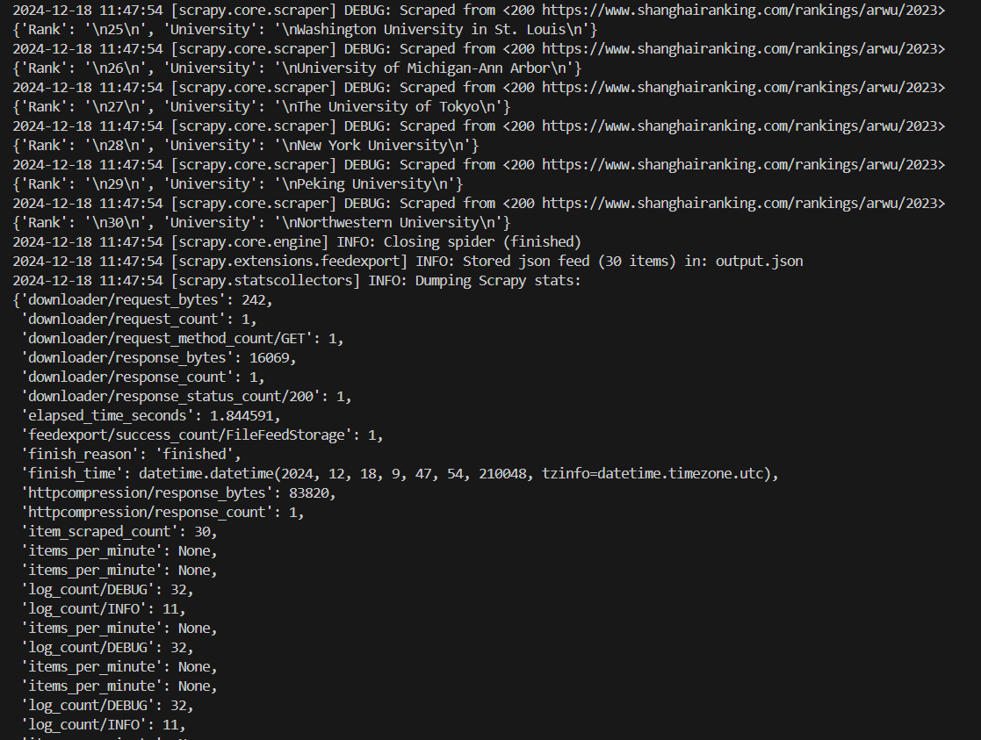

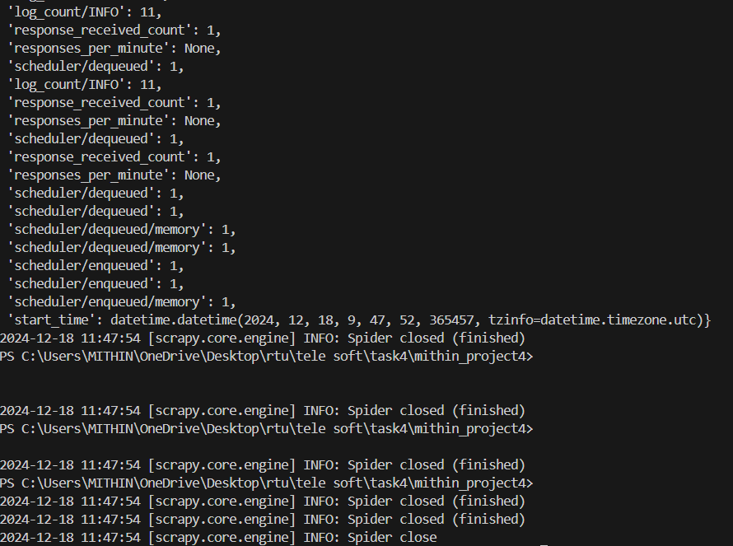

Out put has saved in .json format

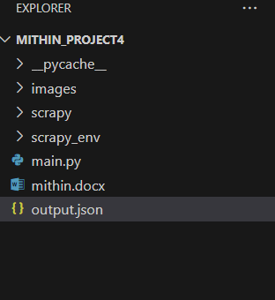

Run the spider to save results

